Making Inferences with Mona Lisa
Natalie F. Masters
Post University - Waterbury, Connecticut

Abstract
This paper will begin with background information on Istation Reading and on the specific lesson to be designed. It will then provide an outline for a lesson on making inferences, intended as an intervention lesson for middle school students who have not yet demonstrated mastery of this critical reading comprehension skill. The outline will include an overview of the lesson, including its purpose, objective statements, rationale, and method of delivery, including considerations of student use of the program within a typical school setting. The learning activities outline will preview the instructional events for the particular lesson, in storyboard form. Finally, this paper will include a reflection on the integration of technology into this lesson as an outcome of learning and a brief description of the instructional designer’s expectations for the final product.

Making Inferences with Mona Lisa
Istation provides reading assessments and individualized instruction for pre-K through high school students. Istation Reading consists of an interactive, computer-based program as well as a comprehensive series of teacher-directed lessons (Istation, 2012). Currently in development is Timeless Tales with Paige Turner, an interdisciplinary reading intervention designed for struggling students in grades 6-12.
Timeless Tales with Paige Turner is designed to support student achievement in reading. The curriculum aligns with state and Common Core standards in English Language Arts and Reading. The curriculum also aligns with Istation’s ISIP-AR assessment, a progress-monitoring tool. ISIP-AR, or Istation’s Indicators of Progress – Advanced Reading, is an automated computer-adaptive test to which students are automatically routed at set points throughout the school year, depending on the level of product purchased and the assessment and instructional goals outlined by school administrators (Istation, 2012). Ideally, as students progress through the curriculum, their scores on ISIP-AR should demonstrate growth.
The feature character for Timeless Tales, Paige Turner, is an artist, writer, traveler, collector, and storyteller. She is fascinated by storytelling and the archetypal hero’s journey. Paige channels her excitement into creating an ongoing graphic novel series. Paige deeply believes in the potential hero within everyone. Paige deliberately studies the craft of storytelling and shares her knowledge at every opportunity (Masters, 2012).
The ultimate goal of Timeless Tales is that students who have struggled in traditional classroom environments will learn, internalize, and generalize vital reading comprehension strategies that will serve them and support their success in future academic endeavors as well as in their lives and careers.
Lesson Purpose and Background
Timeless Tales is designed not only to teach students skills mastery, but also to teach them the self-regulation and metacognitive strategies they need for real reading comprehension and critical thinking. By explicitly teaching metacognitive strategies, Timeless Tales is designed to support student success, not only within the curriculum itself, but also in the broader academic environment and in authentic and real-life scenarios.
The Timeless Tales curriculum consists of ten units of instruction. These units span themes related to humanities and social studies from prehistoric times to the present, and include a variety of fiction and nonfiction texts. Each unit contains two main reading comprehension lessons. The first lesson targets a comprehension skill which aligns with the lower three knowledge levels on Bloom’s Taxonomy: remembering, understanding, and applying. The second lesson in each unit targets the higher three levels on Bloom’s Taxonomy: analyzing, evaluating, and creating (Chapman, 2008-2010).
The first lesson in Unit 1 (Lesson 1.1A) targets the skill of sequencing, or putting the events in a text in order. The second lesson in Unit 1 (Lesson 1.1B) targets the higher-level skill of making inferences. Lesson 1.1B is delivered online and teaches students to follow a metacognitive process to make inferences about the world and about the texts they read (Istation, 2013).
Lesson 1.1B Objectives
Lesson 1.1B aligns with state and Common Core standards which require that students make inferences about the texts they read (Common Core State Standards Initiative, 2013). The Texas state standards in particular emphasize the importance of making inferences as a critical step toward overall mastery of reading (Texas Education Agency, 2009).
Specifically, the objectives for Lesson 1.1B are:
- Students will read closely to determine what the text says explicitly and to make logical inferences from it; cite specific textual evidence when writing or speaking to support conclusions drawn from the text (Common Core State Standards Initiative, 2013) .
- Students are expected to make inferences about text and use textual evidence to support understanding (Texas Education Agency, 2009).
- Students use a flexible range of metacognitive reading skills in both assigned and independent reading to understand an author's message (Texas Education Agency, 2009).
Lesson 1.1B Structure
The targeted lesson begins with Paige Turner introducing the academic terms students need to understand in order to successfully complete the lesson. The terms segment for Lesson 1.1B defines the terms “surface meaning,” “deeper meaning,” and “making inferences” using an interactive four-square vocabulary format with animated examples.
Students interact with the “four-square” model as each piece of information about each term is revealed. The goal is not only to introduce the terms, but also to introduce students to the metacognitive processes involved in mastering the skill(s) to which the terms relate. By using a specific, repeated strategy for learning terms, the program encourages students to use this strategy on their own.
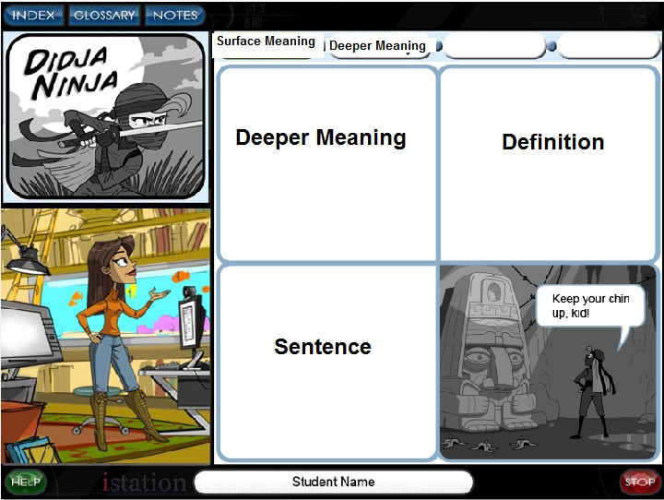
Figure 1
The lesson then demonstrates Paige Turner, as the heroic character “Didja Ninja,” making a simple inference within the context of an animated graphic novel. During this instructional segment, Paige provides explicit instruction on how to make inferences, specifically through modeling.
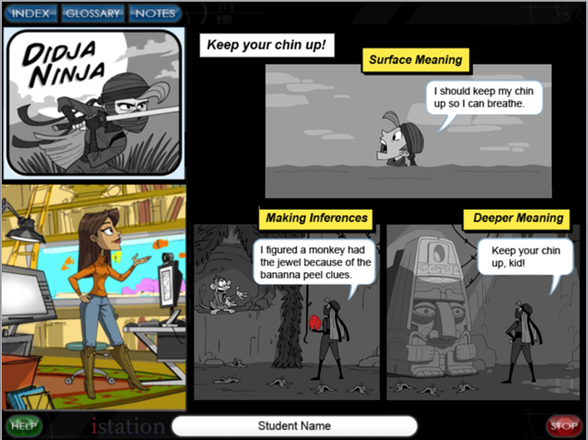
Figure 2
Next, in the guided practice segment, students are presented with an original Istation passage, “Who Stole the Mona Lisa.” This passage, a real-life detective story, is highly engaging, presents a narrative approach to a true historic event, and offers multiple opportunities for students to make inferences about what they read. This guided practice segment will form the primary focus of the instructional outline contained here.
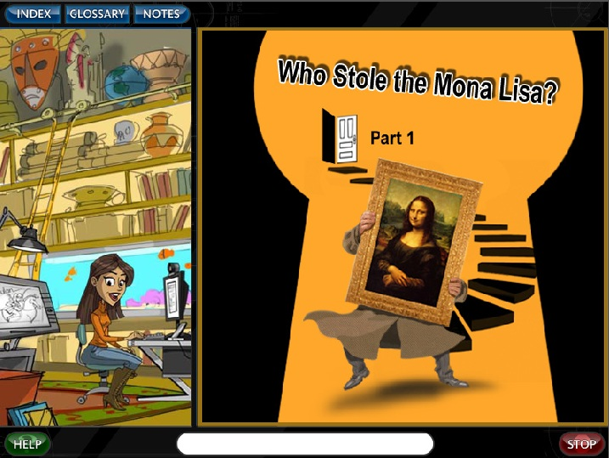
Figure 3
Finally, during the independent practice, or assessment piece of Lesson 1.1B, students read a passage and then answer questions. This section is designed to mimic state assessments and Istation’s ISIP-AR assessment tool. The independent practice segment collects data from student responses for immediate, direct-to-teacher reporting tools used to route students through the curriculum according to their demonstrated mastery of each skill. The independent practice segment is a summative assessment of student mastery of the metacognitive tools and strategies taught in the lesson. In Lesson 1.1B, students practice completing the Iceberg Organizer to make inferences.
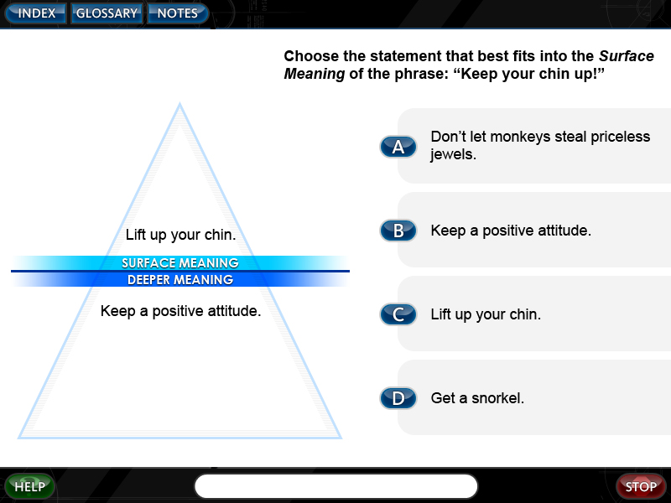
Figure 4
Lesson Delivery and Time Frame
Like all Istation Reading lessons, Lesson 1.1B is delivered online. Students typically interact with the curriculum in a computer lab setting, using headphones. Sometimes, students use the program in their classrooms. The program is also available on the iPad, which can be used in the school setting or at home. Students can access the program from home, given login information is provided by their teachers for such use. The program follows a linear path, but students’ individual experiences are somewhat driven by their responses in the program.
Based on text fluency standards for middle school students whose reading level falls two or more grade levels below, if presented the guided practice passage alone, students should be able to read the 2,025-word passage in ten to fifteen minutes. Because instructional dialogue, interactive activities, and questions are also presented, it can be presumed that students will likely spend anywhere from forty-five to ninety minutes in this lesson. A typical school implementation allows for two or three thirty-minute sessions on Istation each week. Therefore, the lesson design must allow for logical stop points so that students who log out and then reenter the lesson have access to the support and information they need to be successful, even if time passes between logins.
In the event that students must log out of the program mid-way through the lesson, Istation will save their stop points and respond accordingly. Stop points will be built into the program following the “four-square” academic terms segment, the “Didja Ninja” segment, at various places within the “Mona Lisa” guided practice segment, and after the independent practice assessment segment.
Guided Practice Instructional Design
Instead of presenting the “Who Stole the Mona Lisa” passage in the guided practice segment to students as a single, complete passage and then presenting students with a series of multiple-choice questions at the conclusion of the passage, instructional designers at Istation took inspiration from the notion of an action maze, as presented through Half Baked Software’s offering, Quandary.
Quandary works by presenting information in small chunks and then asking one or more questions of users. Depending on users’ responses to the questions, they are then guided to the next bit of information. The experience works like a maze because users are presented with decisions at the end of each segment, and their decisions impact the next step in their experience (Half Baked Software, 2003-2009).
Istation uses proprietary software to deliver instruction to students, and therefore, students’ experiences are relatively predetermined. While their responses are calculated and do impact their overall routing through the program, the nature of the curriculum itself is linear. The redesign for the guided practice segment, therefore, can be loosely modeled after the Quandary concept, but with some modifications.
Lesson 1.1B will present “Who Stole the Mona Lisa” in small chunks. As each section is presented, students will encounter a visual environment related to that section. For example, when the guards question the mysterious man with the mustache, the environment in which students find the text will be illustrated with all the details of this event. When the art dealer meets the Italian man in the antique shop, the text will be presented in an illustrated environment mimicking the antique shop. This approach will improve engagement by creating a game-like environment in which students encounter the players in the story both textually and visually, similar to other text-driven role-playing games on the market.
Once a section of text has been presented in this visually engaging environment, students will have opportunities to complete various tasks associated with that section of text. They might be presented with a multiple-choice question asking them to make an inference about what they just read. They might be instructed to pull out their virtual notebooks and make a note of the clues discovered in that section of text. They might be asked to record a personal reflection about what they have read in that section. Their responses will then drive the experience to the next section of the passage, operating similarly to Quandary, but in a sort of mocked-up manner.
In the event that students must log out of the program before completing the lesson and return at a later date, they will be presented with a recap of the events which have taken place so far in the story, and they will be encouraged to review their notes and their responses to questions so far, which will have been saved in the program.
The overall approach is a hybrid of a role-playing game experience, an action maze with fixed navigation options, and questioning which promotes annotation, critical thinking, making inferences, and overall reading comprehension. All of the material will be presented in a visually engaging way.
Guided Practice Learning Activities
The guided practice segment will play out as follows. Students will be presented with an illustrated environment containing the first section of the passage.
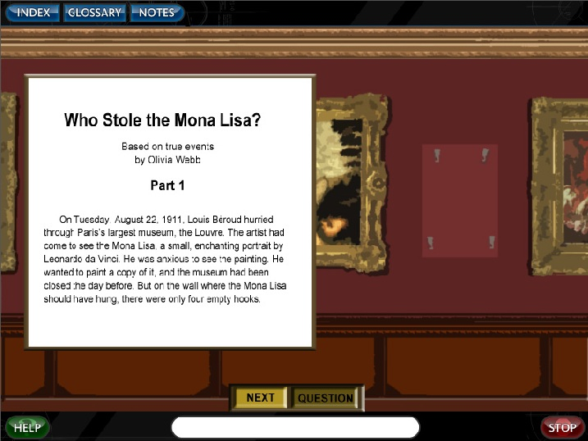
Figure 5
Before moving on in the environment, students will answer a question asking them to respond to the text. The first question will ask students to speculate as to what could have happened to the painting. Their responses will be recorded in their online notebooks.
Then, students will be presented with the next section of text, which will provide an opportunity to infer where the painting may be. After reading this section, to move on, students will answer a question. If they answer correctly, they’ll immediately move to the next section of text. If they do not, the evidence from the text supporting the inference will highlight, and Paige Turner will provide voiceover support in the form of modeling or thinking aloud.
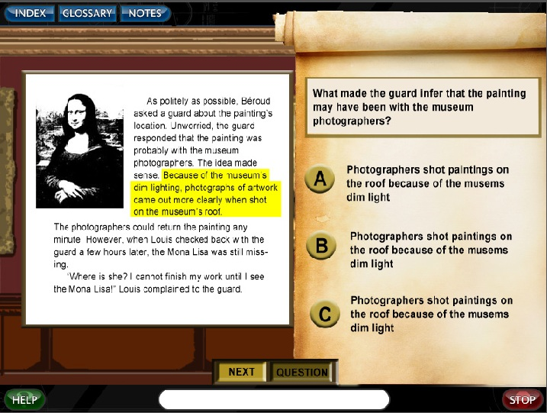
Figure 6
An important feature of this design is that the questions presented at the end of each section of text will not necessarily have right or wrong answers, but will instead promote academic risk-taking and critical thinking. As students continue through the passage, they will be asked to respond to the text in some form or another at the end of each section of text. Some questions will require correct responses, or will then reroute students to specific video and audio feedback and instruction. Other questions will simply require students to respond to the text with their own thoughts and ideas. These responses will route students to their online notebooks, where they will have the option to peruse the information they have collected there so far before moving on. Other responses will simply advance students to the next section of the text.
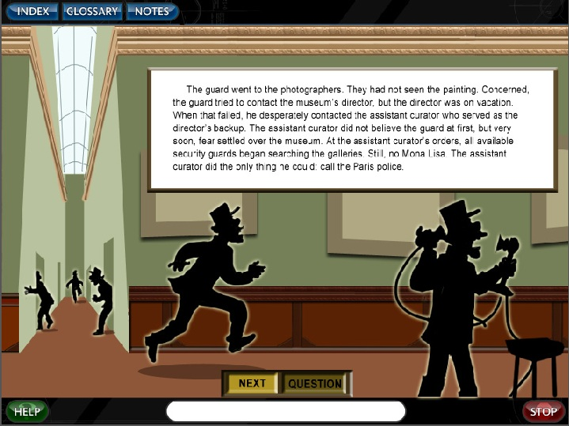
Figure 7
Still other sections will enable students to interact with clues and/or objects in the story, to learn more about those objects and take notes if they desire.
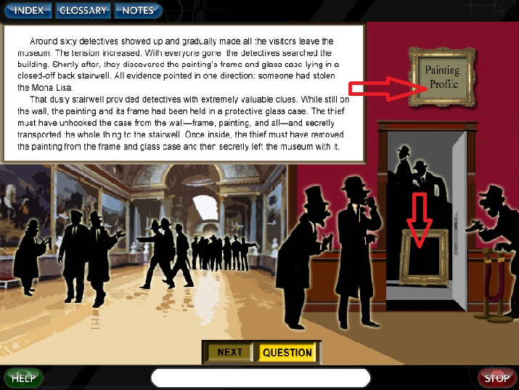
Figure 8
Some sections of text will also enable students to interact with figures within the story to gain more information and clues from those players. In these events, students will click on figures on the screen to learn more, and they will be presented with additional textual and audio information, which they may then record in their notebooks for future reference.
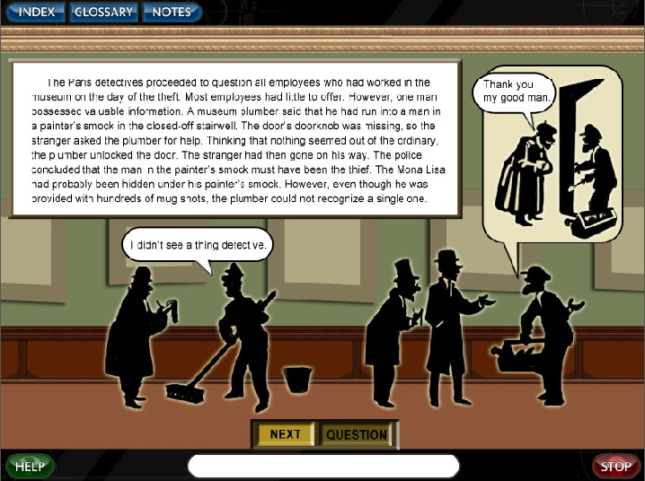
Figure 9
Additionally, students will have the opportunity to engage in learning activities within the lesson to further enrich their understanding of the text. For example, they can interact with the images of newspaper ads and headlines in order to read the rest of the news article or even create their own! In this way, students move beyond the text to exercise critical thinking and inferencing skills in an authentic game-like environment. Enabling students to respond with their own versions of the artifacts described in the text or presented on-screen elevates students’ learning experiences to the highest level of Bloom’s Taxonomy, creating (Chapman, 2008-2010).
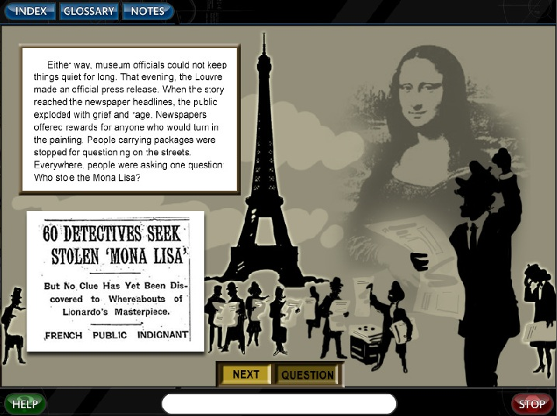
Figure 10
Assessment
Assessment in the lesson will consist of both formative and summative assessment questions, with the primary assessment function being formative. During the guided practice, students will have not only have opportunities to drive their own, individual experiences with the lesson, but will also be presented with opportunities to demonstrate understanding or a need for additional support and instruction. When a need for additional support and instruction is indicated by students’ responses, the program will respond. Students will be able to go back and refer to their notes, specific sections of the text, and will be presented with highlighted text and voiceover, modeling, and think-aloud instruction and support as they think their way through this engaging detective tale. In this way, assessment throughout the lesson will drive students’ instructional experiences.
Once students complete the guided practice segment and move on to the independent practice, the response data Istation collects will also be formative, in that it will help to drive students’ experiences with the curriculum. However, data collection during the independent practice segments will primarily serve a summative purpose, in that it will measure skill growth over time rather than triggering immediate feedback or instructional language.
Benefits of Instructional Design
The instructional design for the “Mona Lisa” guided practice segment is projected to have multiple benefits to students. Even though technological and practical limitations exist in the construct of the described learning experience, at its core, the instructional design promotes student engagement and motivation.
When students are empowered with a sense of control over their own educational experiences, “they feel they have a stake in the outcomes” and this is one of the “most powerful tools [educators] have” (Toshalis & Nakkula, September 2012). Although the Istation technology behind the learning experiences contained in this guided practice lesson does control students’ path through the program and therefore, their experience, the illusion of choice and control may very well be enough to improve motivation.
By asking students reflection questions to which there are no clear right or wrong answers, even in the context of this detective story, instructional designers at Istation hope to achieve elevated achievement by promoting student voice and choice, which has been shown to lead to “better self-reflection and preparation for improvement in struggling students” (Toshalis & Nakkula, September 2012). When a learning activity presents information in manageable chunks rather than an overwhelming volume of information and shifts its focus to open-ended critical thinking questions, for which there are no clear right or wrong answers, the demotivating drudgery of standardized learning activities is counteracted and learning seems to “begin and end with the thoughts, feelings, visions, and actions of the students themselves” (Toshalis & Nakkula, September 2012). This is empowering. And simply, empowerment is motivating.
Reflection
My work at Post University School of Education has dramatically impacted my instructional design practice at Istation. The direct impact of my learning has not been limited to this lesson. However, this lesson serves as a solid example of the benefits of actively seeking and sharing new information which directly relates to one’s educational context and practice.
Six weeks ago when I started EDU 625, Post’s graduate education course on technology integration and learning, the guided practice segments for Timeless Tales were loosely designed to mimic state assessments. They did include some modeling and think-aloud support, but they were not especially engaging for students. The technologies to which I have been exposed in this course have directly impacted my perspective and my goals in designing these lesson segments.
In fact, after researching Bloom’s Digital Taxonomy (Chapman, 2008-2010), and several other educational technology tools through my course readings, I immediately called a meeting with my production supervisors and project managers to request a think tank brainstorming session with our multimedia, art, production, design, and engineering teams. I wanted to capitalize on the technical knowledge, experience, and skills available to me as an instructional designer at Istation in order to develop more engaging lessons that effectively met the instructional objectives of the curriculum.
From these meetings, not only was the redesign of the “Mona Lisa” guided practice segment conceived, but Istation now has seven new working models and storyboards for seven new lesson designs, from reading comprehension to word analysis to vocabulary instruction to assessment. More than twenty members of the Istation team have contributed ideas to the project, and many of those same team members are actively researching current trends in both gaming and in educational technology. The entire Istation office is literally abuzz with fresh, new ideas and a renewed enthusiasm for the work we do.
By taking what I learn and read in this course, and in fact, in all of my courses at Post University, and immediately sharing that knowledge and information with my Istation team, I feel confident that we are better positioned as a company to integrate the best technology we can to create the most engaging and effective reading intervention product we can possibly create.
I expect that as the project develops, we will continue to work together to brainstorm new ideas and to integrate new technology-based experiences for our students, with a strong focus on game-based learning.
I have drafted the script for the “Mona Lisa” lesson, and I expect it to be edited and fully storyboarded in early March for spring production and release in early summer. Once complete, this segment will fit nicely into the existing framework for Timeless Tales, and will give the design and production teams at Istation a first run at creating a new kind of lesson for our students. I expect that we will use this lesson as a learning tool, internally, as we reflect on its effectiveness, production costs and value, and as we introduce it to our market.
Finally, I intend to gather market research using survey tools which specifically ask for feedback on this lesson segment as compared to the guided practice segment contained in Lesson 1.1A. I feel that the best way to build a case for the value of game-based learning activities and the creative presentation of both text and questions in the curriculum is to gather feedback from the teachers and students who use the product. The most important critic Istation has for Timeless Tales is the struggling middle school student himself.
To that end, I intend to publish a working mock-up of the “Mona Lisa” guided practice segment to my PLE and use that as a starting place, combined with an online survey, to extend an opportunity to our customer base to preview and provide feedback on the lesson.
Resources
Additional information about Timeless Tales with Paige Turner and the technology and media incorporated into this lesson can be found at:
http://gen2oh.net/welcome/timelesstales/
http://www.istation.com
http://gen2oh.net/welcome/2013/02/your-story-matters/
http://www.halfbakedsoftware.com/quandary.php

References

Chapman, A. (2008-2010). Bloom's Taxonomy - Learning Domains. Retrieved from Business Balls: http://www.businessballs.com/bloomstaxonomyoflearningdomains.htm
Common Core State Standards Initiative. (2013). English Language Arts Standards: Grade 6.
Half Baked Software. (2003-2009). What is Quandary? Retrieved from Half Baked Software: http://www.halfbakedsoftware.com/quandary.php
Istation. (2012). ISIP-AR. Retrieved from Istation: http://www.istation.com/Assessment/ISIPAdvancedReading
Istation. (2013, June). Istation Reading. Retrieved September 3, 2012, from Istation: http://www.istation.com/Curriculum/ReadingProgram
Kuenster, D. "Who Stole the Mona Lisa, Part 1". Istation, Dallas, TX.
Malamed, C. (2012). Writing Multiple Choice Questions For Higher Order Thinking. Retrieved from The eLearning Coach: http://theelearningcoach.com/elearning_design/multiple-choice-questions/
Masters, N. F. (2011-2013). Timeless Tales with Paige Turner. Retrieved September 2012, from gen2oh.net: http://www.gen2oh.net/timelesstales
McDonald, J., & Gibbons, A. (June 2009). Technology I, II, and III: criteria for understanding and improving the practice of instructional technology. Educational Technolgoy Research & Develoment, 377-392.
Texas Education Agency. (2009). Texas Essential Knowledge and Skills: English Language Arts and Reading (Figure 19). Austin, TX.
Toshalis, E., & Nakkula, M. J. (September 2012). Motivation, Engagement, and Student Voice. Education Digest, 78(1), 29-35.

